Clinic appointment system

Purpose, allow patients to take appointment throught this application.

Allow doctors to visulize the appointments taken and manage their availability.

Program will have three different role login. Each login will be organized in one executalbe(assembly).

Admin login, doctor login, patient login

Process:

Each Doctore will enter his daily availability for the next 4 weeks. This is done periodically.

Admin can do it for doctor if wished.

When doctor enters the availability, database trigger will automatically create default time slots for that date with that doctor Id.

time slots will have a status taken or available. Existing time slots, can be modified by admin (some condition?)

Admin can add/modify non default time slots, say longer duration appointment. (what are the conditions should be checked? If it is conflict with existing default time slots?)

When patient choose a doctor to book appointment, he will see only the available time slots.

Patient can also cancel an appointment if 24 hours before the appointment.

Admin can have full access to all the functionality. Add doctore, register a patient, take an appointment, modify the schedule, add/ modify time slots etc.

Tools:

Visual studio, C# and sql server azure

Library, not sure….

Database diagram

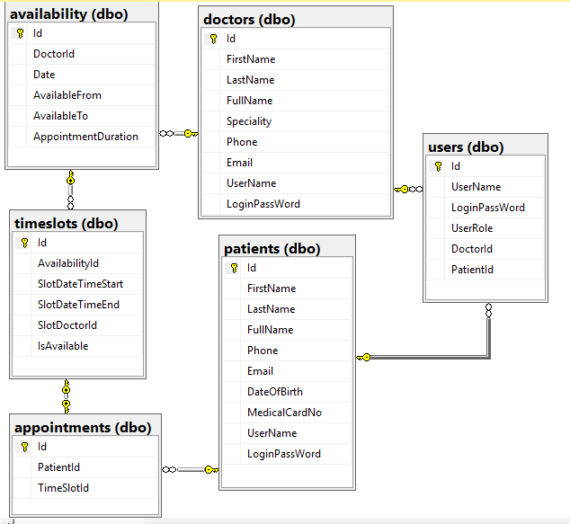

Patient

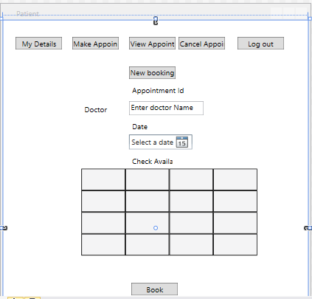

Doctor

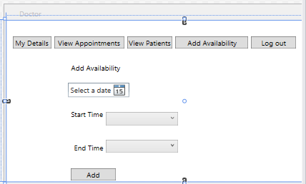

Admin

